1/25/2011 Senior Scientific HCB

Calibration of the SQUID relaxometer

The work described here is a follow-on to the results discussed earlier in a memo of 10/14/2010. In this report we consider a model of the full 7 gradiometer system and use it to extract the SQUID system's average response to a magnetic flux generated in the three rings constituting each gradiometer by test dipoles at various positions in the target space of the apparatus near the axis of symmetry. Two separate data sets were considered: Set 1 taken by Ed Flynn and Set 2 taken by Natalie Adolphi. The results are
Set 1: (1.61 ± 0.09) x 10-13 Weber/Volt and Set 2: (2.75 ± 0.05) x 10-13 Weber/Volt. The errors quoted are statistical. There are probably systematic errors also, in particular a correction for the area of the current loop in the test magnet for Set 1 requires a correction factor estimated to be 1.30 ± 0.07. These results should be regarded as preliminary.

The SQUID sensing circuit for each of the 7 gradiometers is as shown in Fig. 1 (as far as we can determine). The spacing between the distal three loops appears to be somewhat more than a mm, whereas the spacing between the proximal (closest to the "focal" region) three loops appears to be about half of that. We cannot see the central 6 loops. We do not know the reason for this difference in spacing, but it could have a subtle effect on the operation of the gradiometer. In the model discussed below we have simply taken the three sets of loops to spaced 4 cm apart. We treat each set of loops as a single loop.

We number the gradiometers as shown in Fig 2, with gradiometer 1 concentric with the axis of symmetry (z axis). Gradiometers N≠1, identical to 1, are rotated through angle λ about the z axis, starting with the x axis. The increment is 60 degrees. After the z rotation each gradiometer is rotated about its new y' axis by 10 degrees.

In Figs. 3,4 5 we present the mathematics of how the magnetic flux density from a single dipole in the focal region produces a gradiometer flux (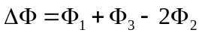). The SQUID turns this signal into a voltage. Our goal is to determine the calibration value for SQUIDs in the system in terms of Webers/Volt. Implicit in this is the assumption that the conversion factor is the same for all SQUIDs.

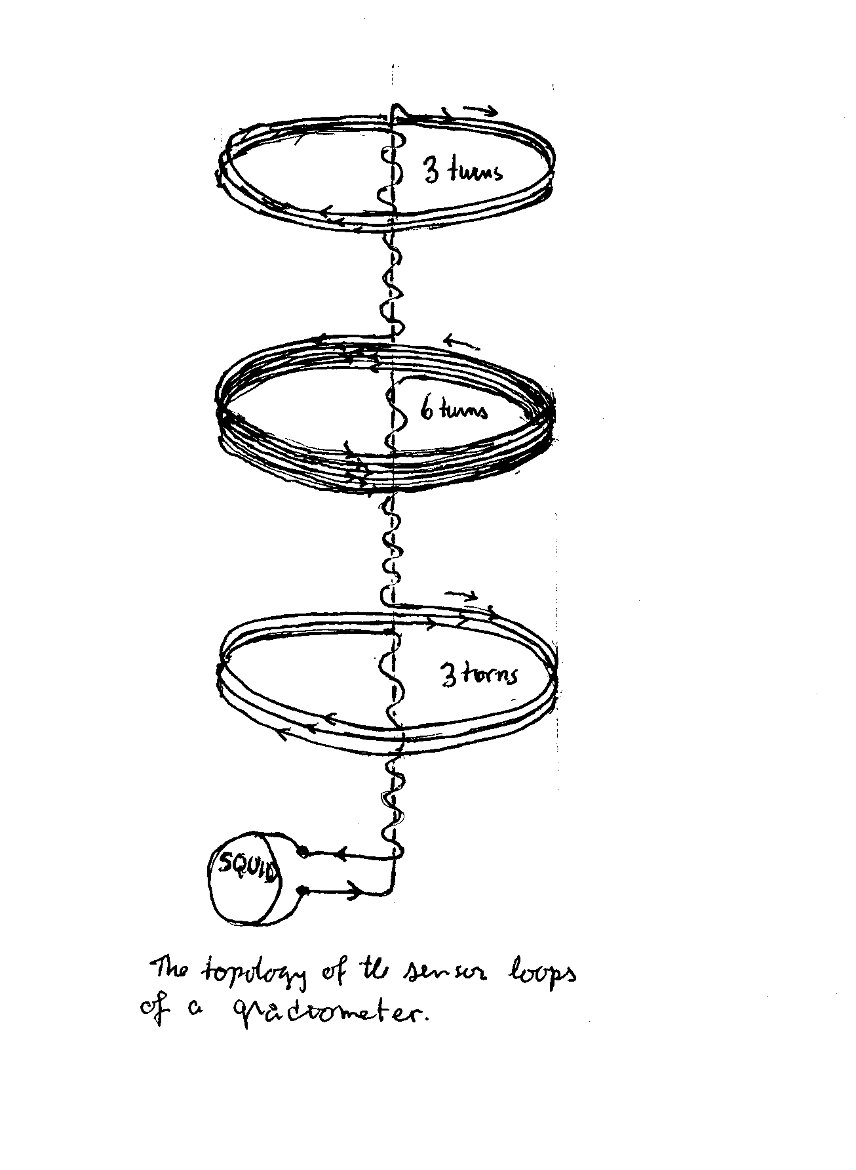Fig 1. Topology of the gradiometer loops.

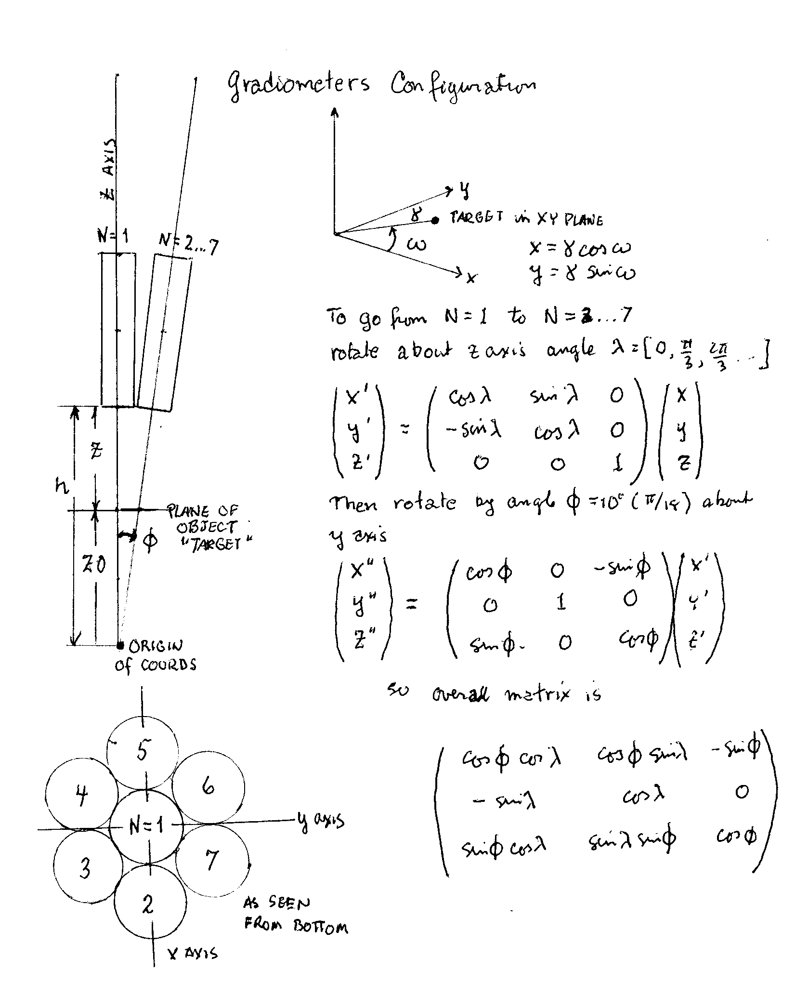
Fig 2. Gradiometer configuration and rotation matrices.

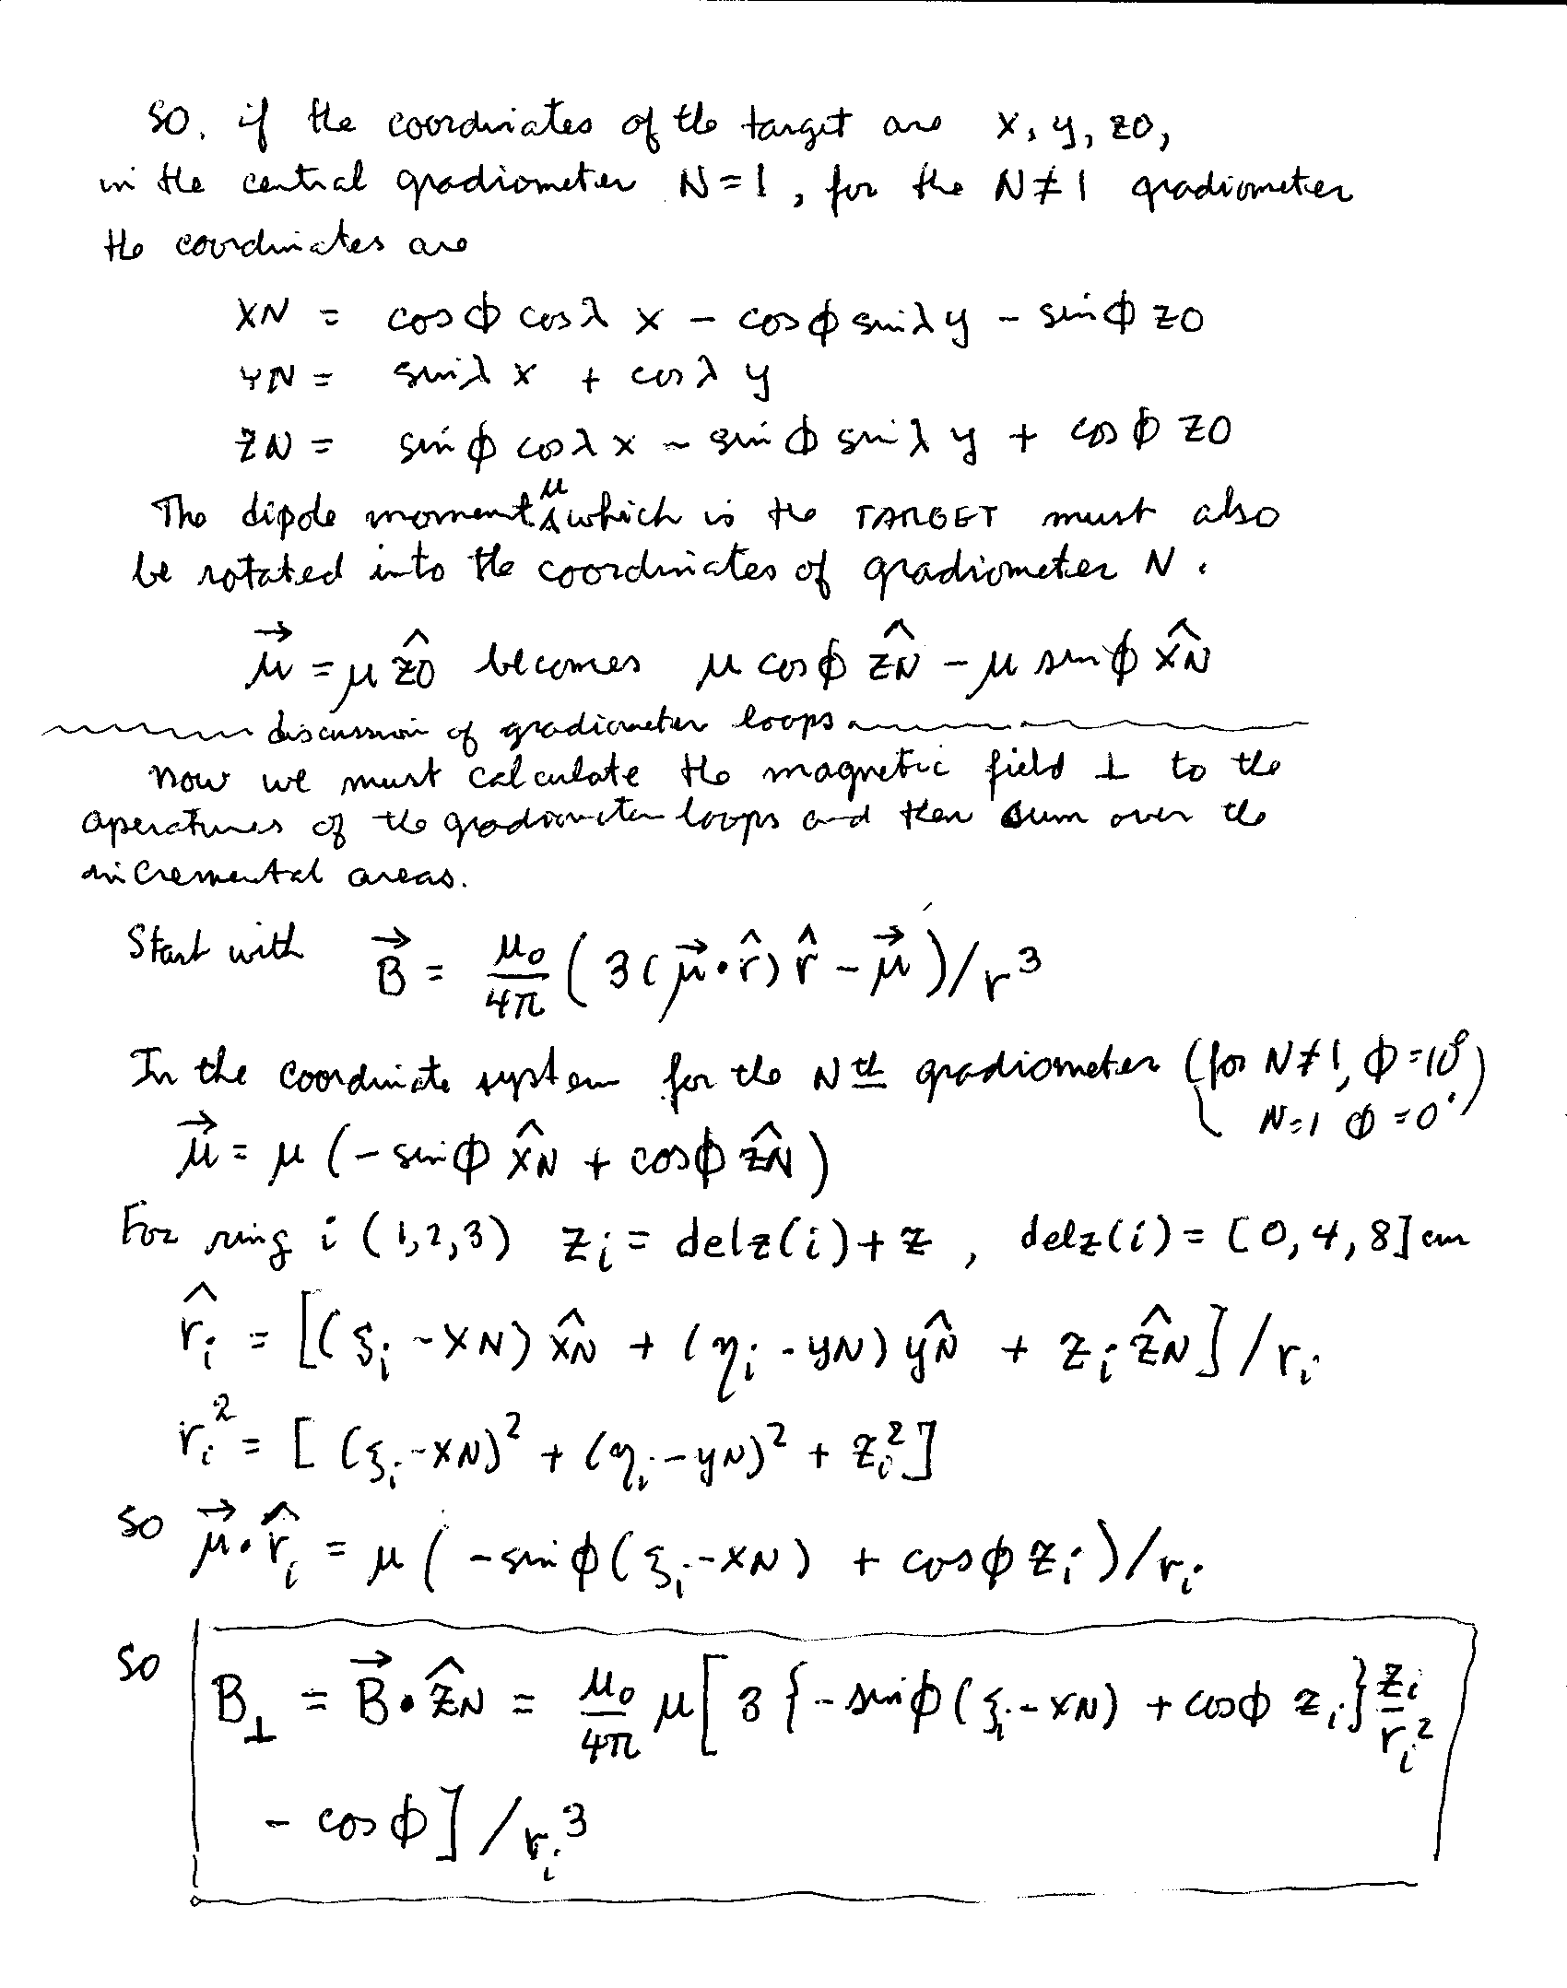Fig 3. Determination of the normal of the flux density from a single dipole aligned along the z axis (axis of gradiometer 1) in the plane of the ith ring. When this is integrated over the area of the ring, it gives the flux.

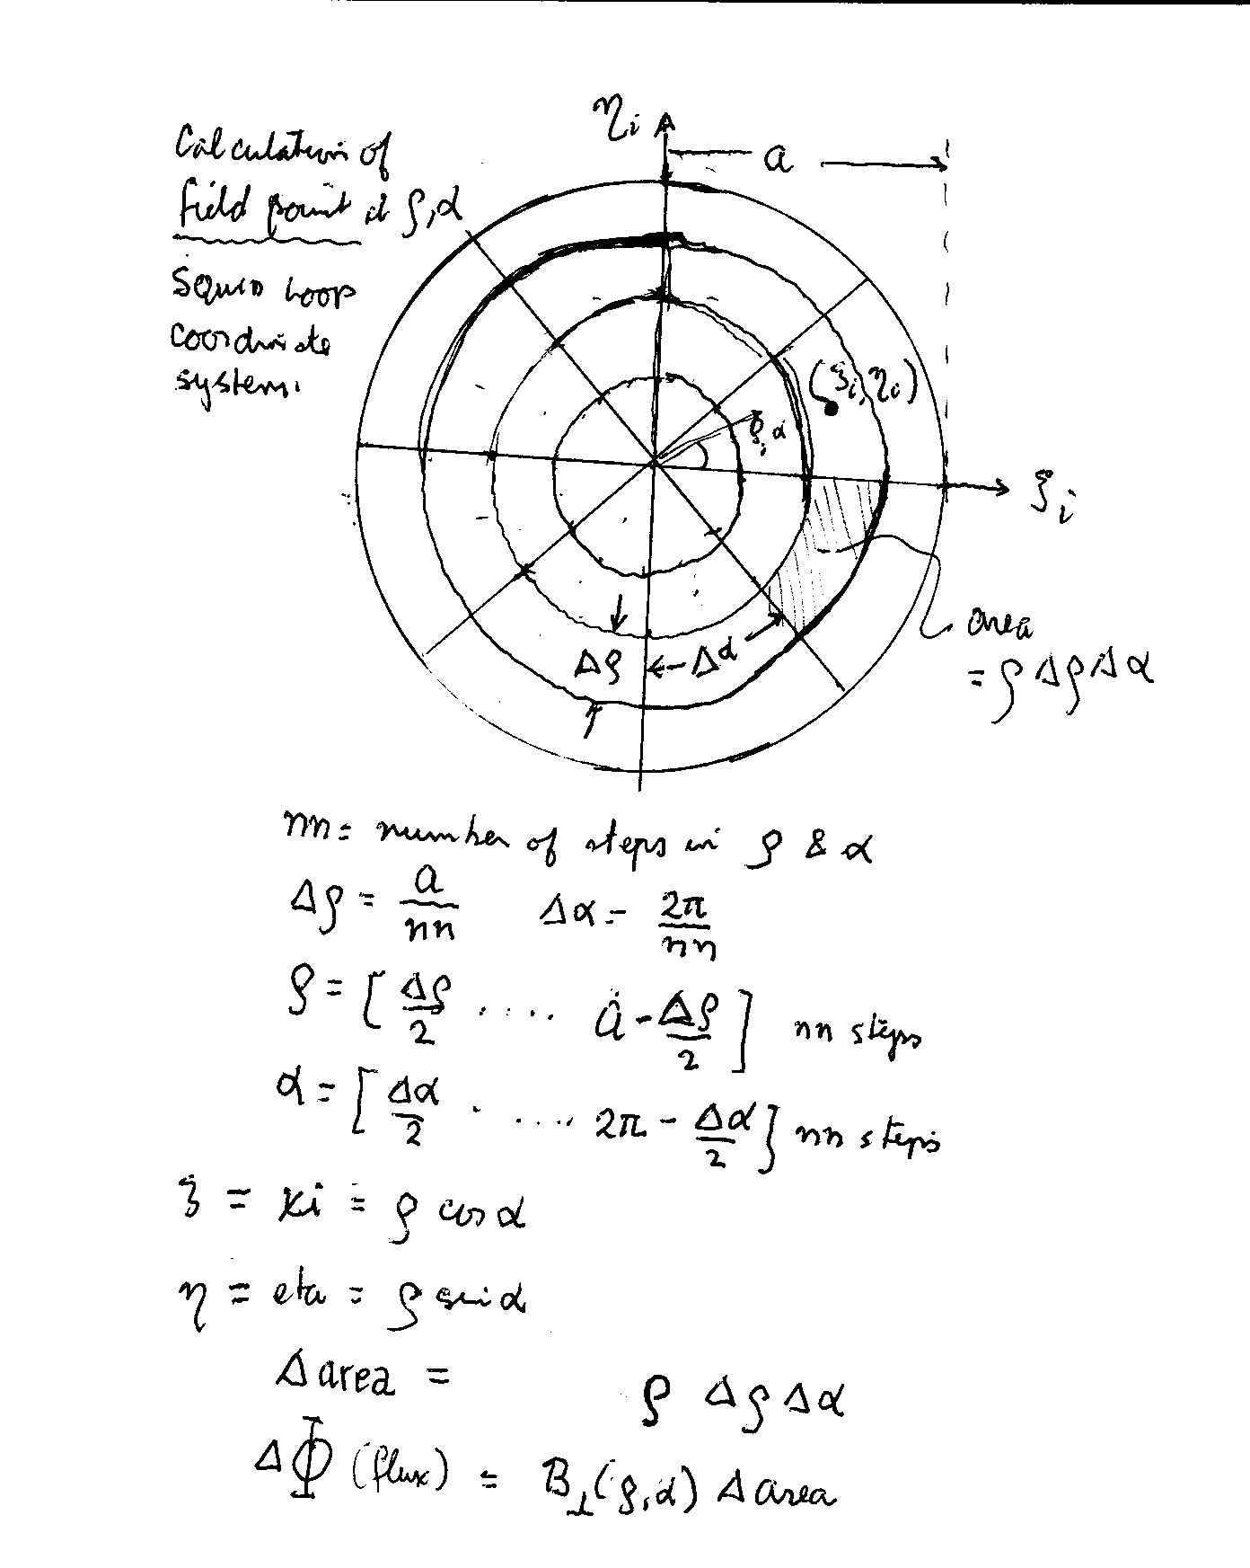
Fig 4. Notation for determining the flux in a loop. The area is first divided into circular sectors and then each bit of flux is denoted by a Cartesian location.

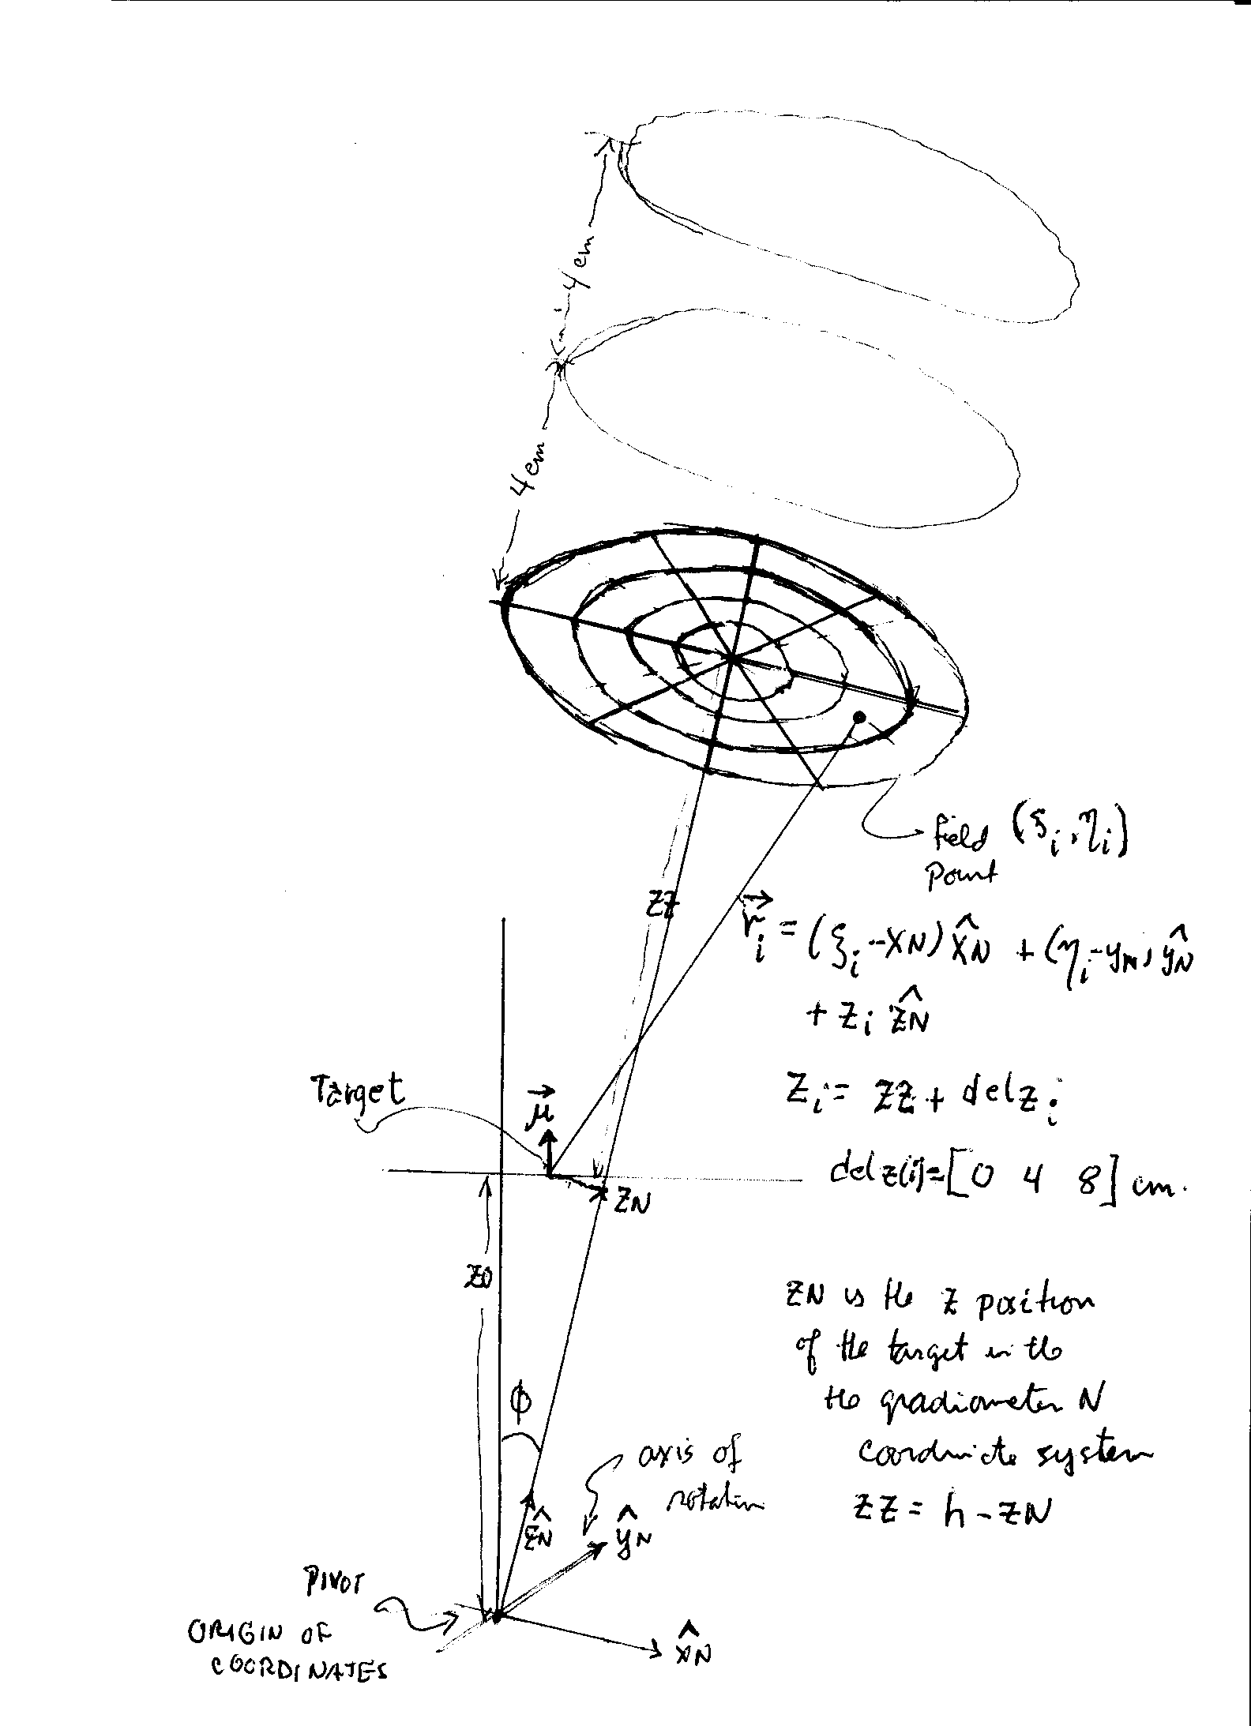
Fig 5. Further illustration of the geometry of an off-axis gradiometer and the notations used in the Matlab program.

In what follows we present the results of the Matlab program that follows the ideas presented above using Ed's data. This program is given in Appendix 1, and contains the details if anyone is interested. A similar program was used to process Natalie's data, which uses only two z coordinates.

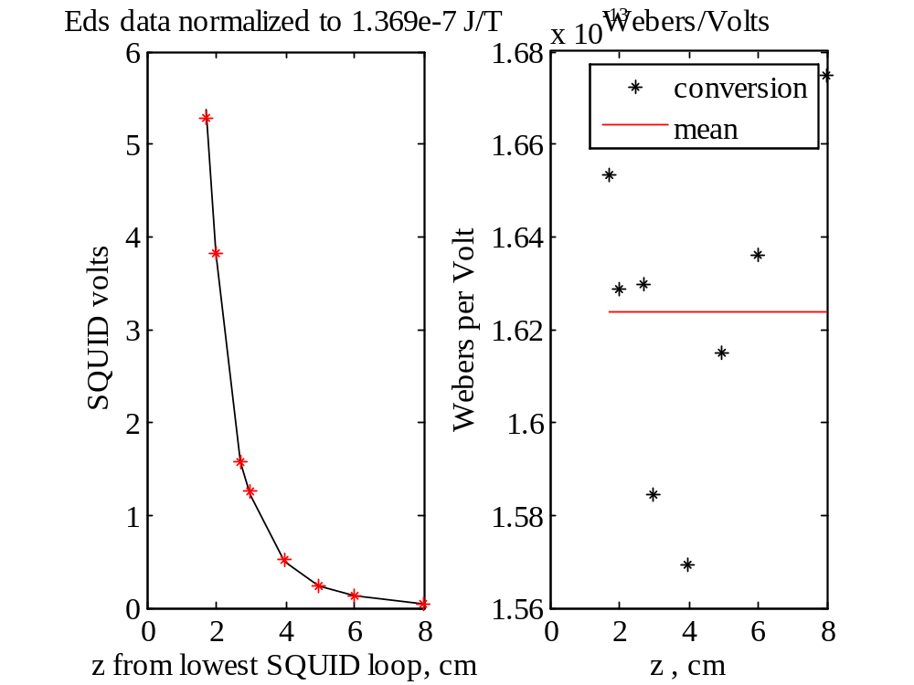

Fig 6. Ed's data N=1

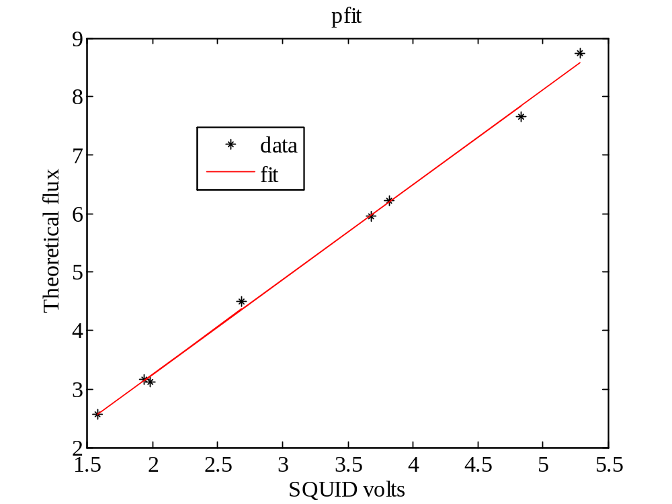

Fig 7. N=1

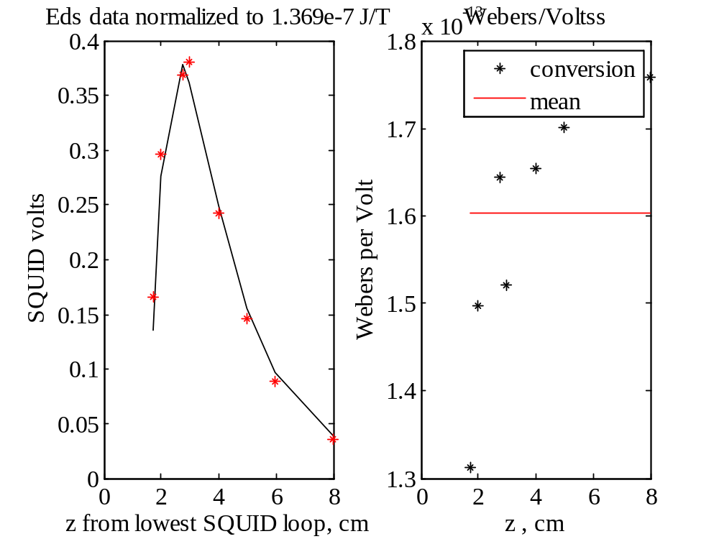

Fig 8. Ed's data N=2

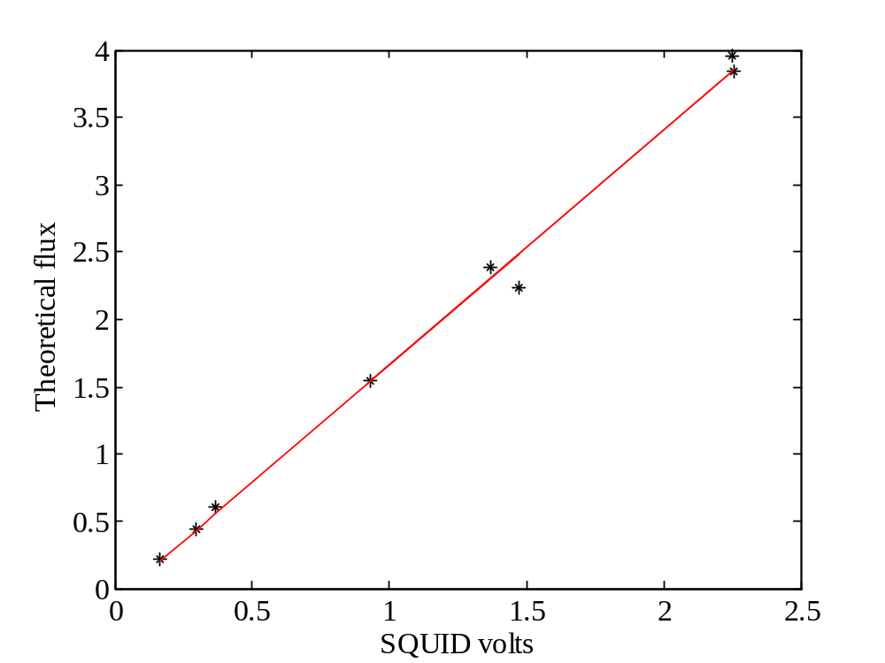

Fig. 9 Ed's data N=2.
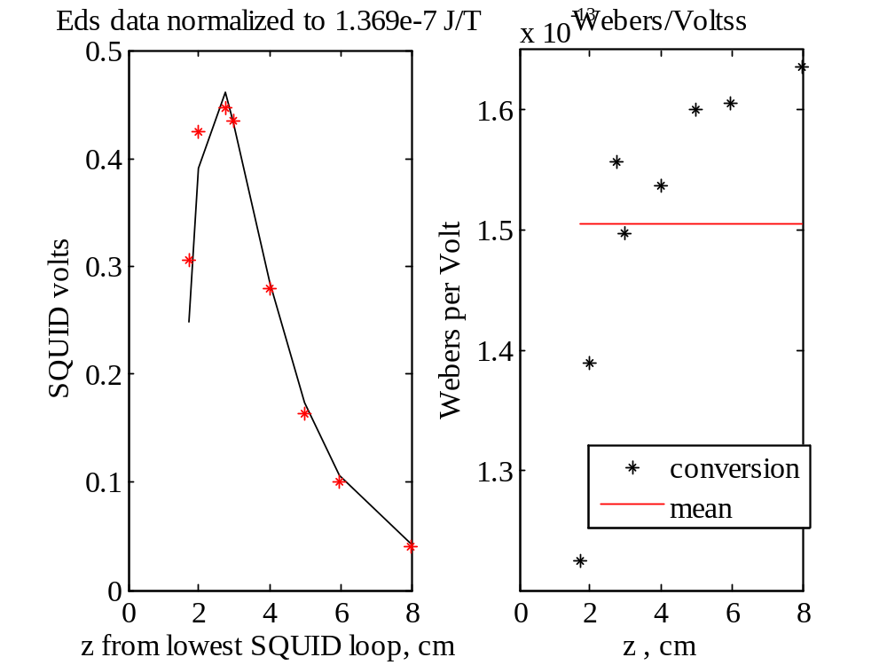

Fig 10. Ed's data , N=3

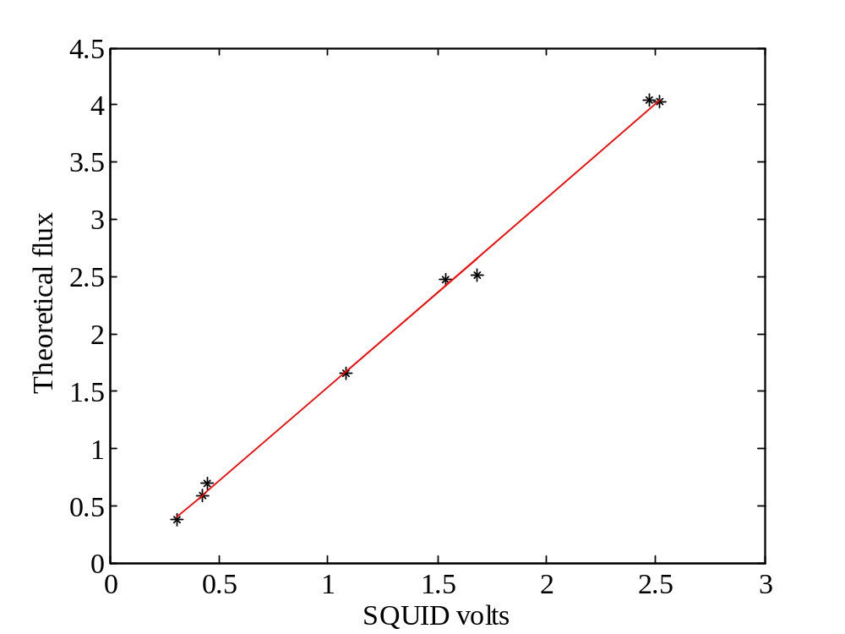

Fig 11. Ed's data. N=3

There is more to do but I need some feedback at this point. HCB.

Appendix 1. <squid_call.m> 1/25/2011

%Rename this as <squid_call.m> 01/03/11. Was <squid_volts_all_flux_S.m> Strip down version N 12/2/10. Putting in my own linear fit with errors 11/23/10
%squid_volts_all_flux HCB 10/26/10 revised <squid_volts_flux.m> 10/14/10 using parts of <squid_sigS_flux.m>
clear all; close all; clc;
%%%%%%%%%%%%%%%%%%%%%%%%%%%%%%%
%This is a modification of <squid_volts_flux.m> to compare with Ed's
%calibration of 12/14/10
%data
%Da=data7;%See page 177, Book 29
%change Da 12/16/10 to
Da=data7test;%see page 187. Also change MM below
run=Da(:,1)';
z_pcd=Da(:,2)';
v1=Da(:,3)';%central gradiometer
v2=Da(:,4)';%side gradiometer
v3=Da(:,5)';
v4=Da(:,6)';
v5=Da(:,7)';
v6=Da(:,8)';
v7=Da(:,9)';
%MM=[1.369 1.369 1.369 1.369 5.283 5.283 21.06 21.06 84.84]*1e-7;%J/T
%omitting first run. go to 8 points now
MM=[1.369 1.369 1.369 5.283 5.283 21.06 21.06 84.84]*1e-7;%J/T
volts=v1;%center gradiometer
%preallocate
voltss=zeros(1,7);%or other side gradiometer
mvws=zeros(1,7);
net_flux_side=zeros(7,length(z_pcd));
nnx=1;%use this to scan x or other variable, now inactive
resultx=zeros(2,8,nnx);
for nx=1:nnx
%delta is used to vary the zero point for the z axis
%delta=-0.45+nx*.025;%cm, to change distance to the lowest coil
delta=-0.375;
delz=[0 4 8]*1e-2;%m. Spacing between three "loops" of gradiometer.
dist=z_pcd+delta;%distance of target in cm from lowest loop of gradiometer
angle=[0 pi/18 pi/18 pi/18 pi/18 pi/18 pi/18];%polar angles phi in radians
lambdas=[0 0 pi/3 2*pi/3 pi 4*pi/3 5*pi/3];%azimuthal angles in radians
% N is the SQUID tube number: N=1 is central, with N=2..7 clockwise
% as seen from top
%lambda=0 for N=1 and 2, otherwise steps of pi/3 ..
%%%%%%%%%%%%%%%%%%%%%%%%%%%%%%%%%%%%%%%%%%%%%%%%%%%%%%%%%%insert call fit
% fitfun=@chifitRealR0;%create handle
% %options=[];%take default options
% %options=optimset('MaxFunEvals',2e3,'MaxIter',2e3,'TolX',10,'TolFun',1e8);
% options=optimset('MaxFunEvals',6e3,'MaxIter',6e3);
% y=C(:,n)';
% %[x,fval,exitflag,output]=fminsearch(fitfun,x0,options,frequency,y);
% x=fminsearch(fitfun,x0,options,frequency,y);
% %compute error norm at returned solution
% enorm(n)=chifitRealR0(x,frequency,y);
% a(n)=x(1);
%%%%%%%%%%%%%%%%%%%%%%%%%%%%%%%%%%%%%%%%%%%%%%%%%%%%%%%%%%

%x=.001*(nx-4);%meters, playing around
%x=.002-(nx*.0001);
%gamma=0.00165+nx*0.000025;%m This is the distance of the test coil from z axis
gamma=.001725;
%omega=1.17+.01*nx;%This is azimuthal angle of test coil position in "lab" coordinates.
omega=1.045;
x=gamma*cos(omega);%meters
y=gamma*sin(omega);%meters
%h=arc/angle(2);%m
%h=12.32e-2;%m, computed from arc distance between two rings from Natalie (see p.125, book 29)
%h=11.46*1e-2;%m using arc of 2 cm, this makes no difference for
%h=12.54e-2;
%h=(13.5+nx*0.1)*1e-2;
h=13.35e-2;
arc=h*angle;%Natalie's number gives 2.15 cm
for nphi=1:7 %1 is central gradiometer, 2-7 is side
phi=angle(nphi);
lambda=lambdas(nphi);
const=1e-7;%mu0/4pi, rationalized MKS stuff.
%central tube.
%probably no better than a percent.
% a is the radius of the SQUID loop: we use a very small radius to find
% field at center of the SQUID
a=0.91*1e-2;%radius in m, (Trace using 2;I measure 1.825 diameter of squid ring.This affects the signal by about 1%.)
%nn=64;%the number of steps in rho and alpha
nn=64;
z=dist*1e-2;%meter
delrho=a/nn;%step in rho
delalpha=2*pi/nn;%step in alpha
rho=linspace(delrho/2,(a-delrho/2),nn);%m
alpha=linspace(delalpha/2,(2*pi-delalpha/2),nn);% radians
%preallocate
r=zeros(3,length(z));
Phi=zeros(3,length(z));
for n=1:length(z)
z0=h-z(n);
M=MM(n);
%rotate coordinates of the target point, see page 131 book 29
%on 12/10/10 I changed some signs in the following rotations so
%that x y z0 form a right-handed system
xn=cos(phi)*cos(lambda)*x+cos(phi)*sin(lambda)*y-sin(phi)*z0;
yn=-sin(lambda)*x +cos(lambda)*y;
zn=sin(phi)*cos(lambda)*x +sin(phi)*sin(lambda)*y +cos(phi)*z0;
zz=h-zn;
for m=1:3
zi=zz+delz(m);
for ma=1:length(alpha)
for mr=1:length(rho)
xi(mr,ma)=rho(mr)*cos(alpha(ma));
eta(mr,ma)=rho(mr)*sin(alpha(ma));
r=(zi^2+(xn-xi(mr,ma)).^2+(yn-eta(mr,ma)).^2).^(1/2);
%field is flux density normal to the squid loop area, B-perpendicular.
%fix sign on bottom of page 181 12/13/10 @5:30 pm
field(mr,ma)=const*M*(3*((xn-xi(mr,ma))*sin(phi)+zi*cos(phi)).*zi./r.^2-cos(phi))./r.^3;%dipole B
darea(mr,ma)=rho(mr)*delrho*delalpha;
end
end
dPhi=darea.*field;
Phi(m,n)=sum(sum(dPhi));%these fluxes depend on na!
end %this is the end of the m loop
signal2=(Phi(1,:)+Phi(3,:)-2*Phi(2,:))/(pi*a^2);%Webers/m2 or Teslas
end %this end of n loop
f=MM(1)./MM;%We use f to normalize the results to a the lowest magnetic moment.
if nphi==1
net_flux_center=signal2*(pi*a^2);
else
net_flux_side(nphi,:)=signal2*(pi*a^2);
end
if nphi==1
vw=net_flux_center./volts;
mvw=mean(vw);
standard_deviation=std(vw);
rat=standard_deviation/mvw;
cf=1/mvw;
subplot(1,2,1)
plot(dist,f.*net_flux_center*cf,'k-',dist,f.*volts,'r*')
title('Eds data normalized to 1.369e-7 J/T')
ylabel('SQUID volts')
xlabel('z from lowest SQUID loop, cm')
%legend('theoretical flux*cf', 'SQUID volts')
subplot(1,2,2)
plot(dist,vw,'k*',dist,(dist./dist)*mvw,'r-')
ylabel('Webers per Volt')
title('Webers/Volts')
legend('conversion', 'mean')
xlabel('z , cm')
%%%%%%%%%%%%%%%%%%
results=[dist' volts' MM'*1e7 net_flux_center'*1e13];
yy=results(:,4);
xx=results(:,2);
p=polyfit(xx,yy,1);
po=[p(1) p(2)];
figure
pfit=p(1)*xx+p(2);
plot(xx,yy,'k*',xx,pfit,'r-')
title('pfit')
legend('data','fit')
xlabel('SQUID volts')
ylabel('Theoretical flux')
%%%%%%%%%
% %estimate uncertainties in the parameters (forlength(z)=2, skip this)
% sigs=(sum((yy-pfit).^2)./(length(xx)-1));
% rms=sqrt(sigs);
% H=zeros(2,2);
% H(1,1)=sum(xx.*xx);
% H(2,2)=length(xx);
% H(1,2)=sum(xx);
% H(2,1)=H(1,2);
% H=H/sigs;
% Hinv=inv(H);
% errp=sqrt(Hinv(1,1));
% errb=sqrt(Hinv(2,2));
result(1,:)=[mvw*1e13 standard_deviation*1e13 rat po x y lambda];
else
%Now do the side gradiometers, "add an s"
%%%%%%%%%
%net_flux_side% temporary
voltss=Da(:,nphi+2)';
vw=net_flux_side(nphi,:)./voltss;
mvws(nphi)=mean(vw);
standard_deviation_s(nphi)=std(vw);
rats(nphi)=standard_deviation_s(nphi)/mvws(nphi);
cf=1/mvws(nphi);
figure
subplot(1,2,1)
plot(dist,f.*net_flux_side(nphi,:)*cf,'k-',dist,f.*voltss,'r*')
title('Eds data normalized to 1.369e-7 J/T')
ylabel('SQUID volts')
xlabel('z from lowest SQUID loop, cm')
%legend('theoretical flux*cf', 'SQUID volts')
subplot(1,2,2)
plot(dist,vw,'k*',dist,(dist./dist)*mvws(nphi),'r-')
ylabel('Webers per Volt')
title('Webers/Voltss')
legend('conversion', 'mean')
xlabel('z , cm')
%%%%%%%%%%%%%%%%%%
%resultss=[dist' voltss' MM'*1e7 net_flux_side'*1e13];
yy=net_flux_side(nphi,:)*1e13;
xx=voltss;
p=polyfit(xx,yy,1);
figure
ps=[p(1) p(2)];
pfit=p(1)*xx+p(2);
plot(xx,yy,'k*',xx,pfit,'r-')
xlabel('SQUID volts')
ylabel('Theoretical flux')
result(nphi,:)=[mvws(nphi)*1e13 standard_deviation_s(nphi)*1e13 rats(nphi) ps h delta phi*180/pi];
ms(nphi-1)=result(nphi-1,1);
end %this is the end of nphi changes; nphi remains the highest
end
%result(:,:,nx)=[ mvw*1e13 standard_deviation*1e13 rat po x y lambda;mvws(nphi)*1e13 standard_deviation_s(nphi)*1e13 rats(nphi) ps h delta phi*180/pi];

result
%figure of merit fom
fom =sqrt(sum((standard_deviation_s*1e13).^2)/6)
means=mean(ms)
stds=std(ms)
mgamma=gamma*1000
omega
delta
h
end

